TASK 2: Multiple Sequence Alignment (MSA)
Tool Used: Clustal Omega (EMBL-EBI)

Introduction
Bioinformatics uses Multiple Sequence Alignment (MSA) as a basic method that enables researchers to compare three or more biological sequences to find matching sequence segments. The detected similarities between sequences show their shared functional and structural and evolutionary ties. Researchers use MSA to examine conserved parts of biological systems and to identify crucial functional elements and to study how species maintain their evolutionary patterns. Researchers have extensively studied hemoglobin as the protein that carries oxygen through blood. Scientists use the hemoglobin alpha subunit because its sequence remains unchanged across all vertebrate species to study multiple sequence alignment. The researchers used Clustal Omega to align hemoglobin alpha protein sequences from five different species which allowed them to find shared amino acid sequences while they studied their functional roles.
objectives
The objectives of this task are: to select protein sequences which exist in the same protein family to use Clustal Omega for Multiple Sequence Alignment to identify amino acid regions which show conservation across different species to explain the biological functions of regions which show conservation in their structure

Materials and Tools Used
• UniProt Database – for protein sequence retrieval
• Clustal Omega (EMBL-EBI) – for multiple sequence alignment
• Web Browser

Methodology
The hemoglobin alpha protein family was selected for this study because all members perform the same biological function of oxygen binding and transport. Selecting proteins from the same family but different species helps in understanding evolutionary conservation.
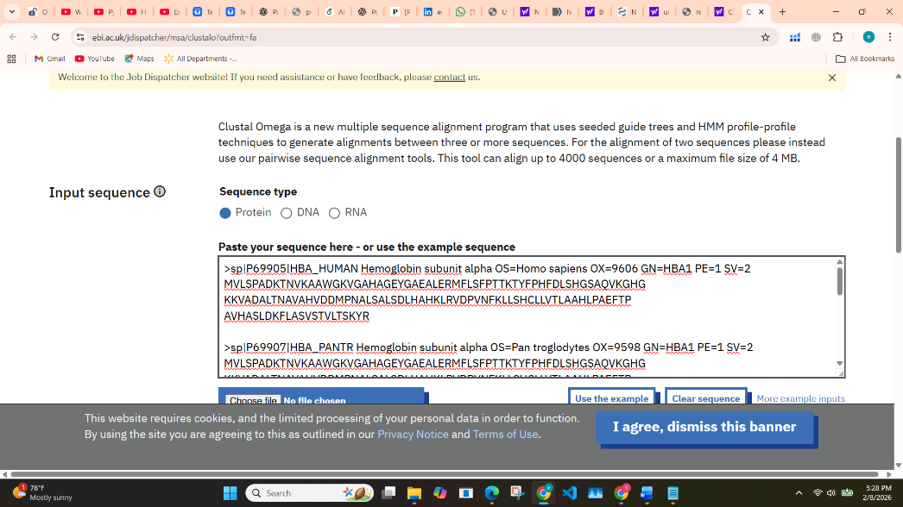

Protein Sequences Used
Five hemoglobin alpha protein sequences were selected from UniProt in FASTA format:
Protein | Species
Hemoglobin subunit alpha | Homo sapiens
Hemoglobin subunit alpha | Pan troglodytes
Hemoglobin subunit alpha | Mus musculus
Hemoglobin subunit alpha | Bos taurus
Hemoglobin subunit alpha | Gallus gallus

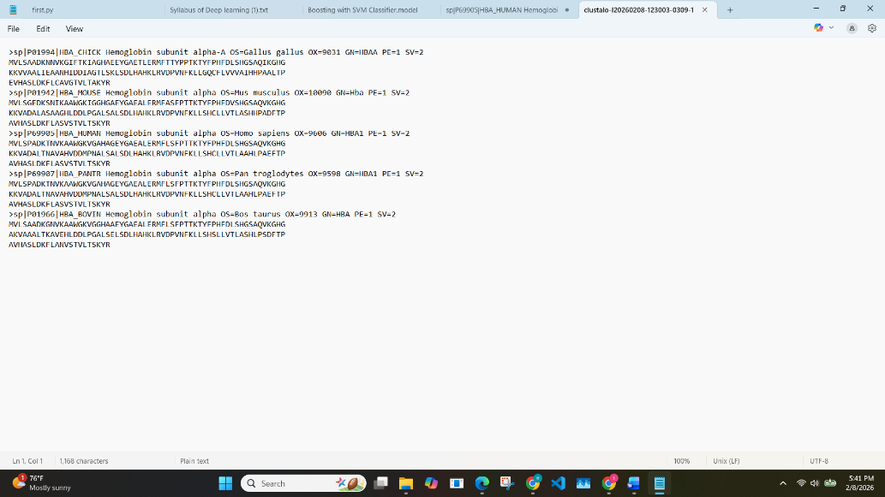
Multiple Sequence Alignment
The collected FASTA sequences were submitted to Clustal Omega, an online multiple sequence alignment tool provided by EMBL-EBI. Default parameters were used for alignment. The output was visualized using the colored alignment (Nightingale view), which highlights conserved and variable regions using color coding.

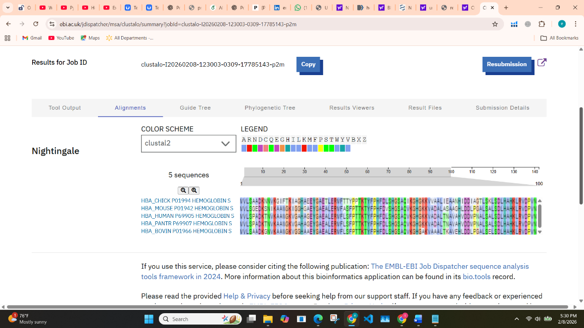

Results
The multiple sequence alignment successfully aligned all five hemoglobin alpha sequences. The alignment showed a high degree of similarity across most regions of the sequences.

Conserved Regions
Several amino acid residues were conserved across all five sequences. These conserved regions were identified by:
- Identical amino acids appearing in the same positions
- Similar color patterns across aligned sequences
The high conservation indicates that these amino acids play an essential role in maintaining protein structure and function.

